|  |
| --- |
| Mothol Consulting |
| Software Requirements Specification | |
| **Mothol Retail Solution** |

|  |
| --- |
| Mahmoud Eldaly  2-2-2020 |



|  |
| --- |
| Mahmoud Eldaly  2-2-2020 |

Table of Contents

RevisionSheet 3

**Change Record** 3

**Reviewers** 3

**Client review** 3

1. Introduction 4

1.1 Purpose 4

1.2 Document Conventions 4

1.3 Intended Audience and Reading Suggestions 4

1.4 Project Scope 4

1.5 Technologies to be used 4

1.6 References 5

2. Overall Description 6

2.1 Product Perspective 6

2.2 Product Features 6

2.3 User Classes and Characteristics 7

2.4 Design and Implementation Constraints 8

2.5 User Documentation 8

3. System Features – Administration module (Back office) 9

3.1 Stores Configuration 9

3.2 Master Data 9

3.3 Transactions 10

3.4 Synchronization and Real time Services 10

4. System Features – Point of sale 10

4.1 Store Configuration 10

4.2 Synchronization and Real time Services 10

4.3 Transaction operations and details 10

4.4 Transaction line operations and details 13

4.5 Payment 15

4.6 Shift operations 17

4.7 Discount operations 19

4.8 Customer operations 20

4.9 Other operations 20

4.10 Time clock operations 22

4.11 To be consider 22

5. External Interface requirements 24

5.1 User Interfaces 24

5.2 Hardware Interfaces 24

5.3 Software Interfaces 24

5.4 Communications Interfaces 25

6. Other Nonfunctional requirements 26

6.1 Performance Requirements 26

6.2 Safety Requirements 26

6.3 Security Requirements 26

6.4 Software Quality Attributes 26

7. Other requirements 27

Appendix 28

Diagrams 28

# RevisionSheet

## **Change Record**

|  |  |  |  |
| --- | --- | --- | --- |
| **Date** | **Author** | **Version** | **Change reference** |
| 02/22/2020 | Mahmoud Eldaly | V1.0 | POS application requirements |
| 02/24/2020 | Amr Metwally | V1.0 | POS application requirements |
|  |  |  |  |
|  |  |  |  |
|  |  |  |  |

## **Reviewers**

|  |  |  |
| --- | --- | --- |
| **Name** |  | **Position** |
| Mr. Usama Mari |  | General Manager |
| Eng. Hossam Eldin |  | MIS Manager |
| Eng. Amr Metwally |  | Development Section Head |

## **Client review**

|  |  |  |
| --- | --- | --- |
| **Name** |  | **Position** |
| Mr. Mahmoud Aboud |  | Business Development Manager |
|  |  |  |
|  |  |  |

# Introduction

## Purpose

The main purpose for this document is to present a detailed description for our new product **MOTHOL RETAIL SOULTION – MRS** to guide development team to develop outstanding retail solution that will flexible to use with various business types and fully integrated with current ERP System (Microsoft Dynamics AX 2012 r3)

## Document Conventions

This Document was created based on the IEEE template for System Requirement Specification Documents.

## Intended Audience and Reading Suggestions

* This document is intended for use by
  + Programmers, developers and software testers who are interested in working on the project by further developing it or fix existing bugs.
  + Stakeholders and project consultants who are associated with **MRS**

## Project Scope

* New POS application that will help cashier and manager to handle daily sales with basic sales transaction and payments
* Two-way synchronization services that will syncs all data between HQ database and stores immediately or using schedule
* Integration module between HQ database and current ERP System (Microsoft Dynamics AX 2012 r3) that will handle which mater will be synced

## Technologies to be used

|  |  |
| --- | --- |
| Database | Microsoft SQL Server 2014 or higher |
| Programming Language | C# .Net |
| Interface | Windows Presentation Foundation (WPF) |
| Synchronize | What Is Windows Communication Foundation (WCF) |
| Framework | .Net Framework 4.6 or higher |
| Operation System | **For Store**: Windows 8.1 or higher  **Fore HQ:** Windows Server 2012 or higher |

## References

* Operation list: provided by MIS team to describe more details for each operation
* Mothol_retail_phases: provided by MIS team to clarify features by each phase

# Overall Description

## Product Perspective

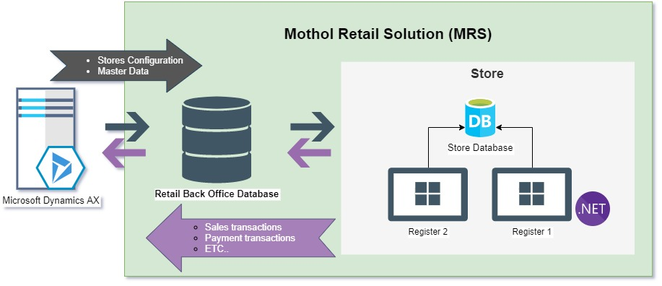

* + 1. Administration module (Back office)
* The Administration Module provides facilities for the administrator and key users to manage the master data and store details.
* Including configure products, prices, customers, promotion, gift cards and loyalty program.
* View reports for all stores such as sales and promotion reports.

Note: First release for MRS will use current ERP System (Microsoft Dynamics AX 2012 r3) to create and modify master data

* + 1. Point of sales (POS)
* POS application considered as the transactions module that provides facilities for the cashier and manager to record and manage customer orders.

## Product Features

Below are summarize list for the major features the product contains, Details will be provided in section 3 – System features

* Sales transaction and payment operation
* Sales returns management
* Commission Management
* Centralized store management
* Pricing and Promotions
* Loyalty Program
* Email Marketing
* Employee Management
* Purchase Order Management
* Reporting/Analytics

Note: First release will contain only basic features that provided on Mothol_retail_phases document

## User Classes and Characteristics

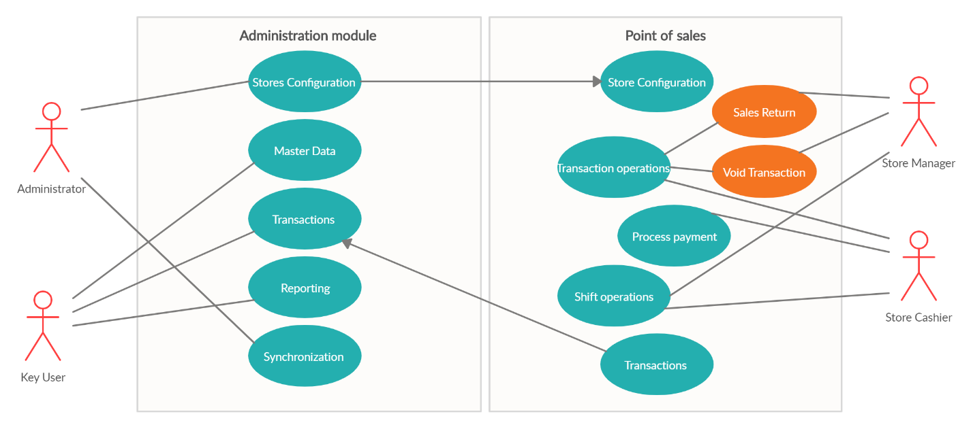

* + 1. Administrators
    2. Key users
    3. Managers
    4. Cashiers

## Design and Implementation Constraints

* Each store must have Offline database
* Able to determine the synchronize schedule for each store
* Transaction able to be like real time as possible

## User Documentation

Below is the list of user documentation that will be delivered along with the software

* User manuals
* POS Tutorials

# System Features – Administration module (Back office)

## Stores Configuration

* + 1. Description and Priority
    2. Functional Requirements
       1. Stores
       2. Cashier
  + Basic configuration
  + POS Permissions
  + Assigned stores (Address books)
    - 1. Screen Layout
      2. POS Registers
      3. Receipt Formats
      4. POS Operations
      5. Payment Methods
  + denominations
    - 1. Loyalty
      2. Gift cards

## Master Data

* + 1. Description and Priority
    2. Functional Requirements
       1. Products (Assortments concept)
       2. Pricing and discounts
       3. Customers
       4. Currency
       5. Reason codes
       6. Tax

## Transactions

* + 1. Description and Priority
    2. Functional Requirements

## Synchronization and Real time Services

* + 1. Description and Priority
    2. Functional Requirements
       1. Synchronization between HQ and stores
       2. Integration between Dynamics AX and HQ
       3. Product Availability

# System Features – Point of sale

## Store Configuration

## Synchronization and Real time Services

## Transaction operations and details

* + 1. Description and Priority

Users can use the POS to create sales and return transaction through the main screen, there are a lot of data should be viewed and stored when sales or return transaction created

Below are the transaction details needed to be saved

* + *Transaction* details
  + Store ID
  + Shift ID
  + Register ID
  + Transaction ID
  + Transaction comment
  + Currency
  + Customer Account
  + Total Discount amount
  + Gross Amount
  + Sales tax
  + Net Amount
  + Number of product lines
  + Number of products
  + Payment amount
  + Amount to customer
  + Receipt ID
  + Reference
  + Sales Rep – Cashier ID
  + Staff (Cashier ID)
  + Transaction date and time
  + Transaction Type
    - Order
    - Sales
    - Return
  + Transaction Status
    1. Functional Requirements
  + *By default, each transaction should contain cashier ID*
    - *This operation can be used to choose the sales rep from available cashiers in this store, this selection will be used for all transaction lines that are added later*
  + *Clear sales representative on transaction*
  + *Add product* 
    - *This operation can be used to add specific product to current transaction there’re more then way to add product*
      * *Scan product barcode*
      * *Enter item number or barcode manually on numpad bar then click return*
      * *From search product screen using add product button*
      * *From price check screen using add product button*
      * *From inventory lookup using add product button*
      * *From product details screen using product button*
    - *When add new product on transaction price may change according to selected customer*
    - *Discounts and promotions executed from HQ should applied when add new product to transaction*
  + *Transaction comment*
    - *This operation can be user to add comments current transaction*
    - *For many reasons, it’s required to add information about transaction*
    - *In addition, we need to configure transaction comment as a mandatory for specific sales scenario such as the reason to void or suspend transaction*
  + *Void transaction*
    - *For any reason after cashier added items to transaction, the customer has decided to cancel entire transaction at this time cashier need to void this transaction*
    - *The cashier will click void transaction*
    - *The Cashier will be asked to choose reason code to void transaction*
    - *The cashier will be asked to confirm voiding entire transaction*
    - *The transaction will be stored on database with status voided and will not printed a receipt*
    - *Before void transaction, all payment transaction should be voided by cashier*
    - *It's important to note that the permissions for the cashier will need to be configured correctly to allow transaction voiding based on sales process*
    - *If the cashier doesn’t have the permission to void transaction, new screen will open to enter manager user name and password to complete this operation*
  + *Suspend transaction*
    - * *For many reasons cashier need to use suspend transaction operation for example, if customer need to add products to his order but he will pick it first from inside the store and cashier need to serve the next customer , or the customer needs to go out to their car because he forgot his wallet.*
      * *Before suspend transaction, all payment transaction should be voided*
      * *When cashier suspend a transaction, it can be recalled later on by using the recall transaction function.*
      * *Maybe we need to configure POS to ignore close the current shift if any suspended transaction exists*
  + *Recall transaction*
    - * *When the customer is back and ready to finish his transaction, the cashier can use recall operation to choose transaction form suspended transaction*
      * *The suspended transactions can be called form any register inside the same store*
      * *After cashier recall transaction he can add payments to finish transaction*
  + *Return product*
    - * *The operation can be used to add product to current transaction with negative quantity without link with pervious transaction*
  + *Return transaction*
    - * *This operation can be used to return sales transaction that are created from current store or any other retail store*
      * *Cashier can perform to return an entire transaction or just specific lines and items from a transaction*
      * *There are two ways to return transaction to choose from transaction list or enter or scan receipt ID*
      * *Once you've selected a valid receipt, the system will display a screen with the returnable items. Then you can mark the checkbox next to each item that you want to return. Then click return items. This will create a new line on the transaction with negative quantity.*
  + *Calculate total*
    - * *This operation can be used to check if all discount and promotion are applied for current transaction and calculate total amount for transaction*
  + *Display total*
    - * *After end of transaction cashier can use this to the balance of transaction on the customer display*

## Transaction line operations and details

* + 1. Description and Priority

There are several different actions that the cashier can take to edit transaction lines at the point of sale register.

* + *Transaction line details*
  + Store ID
  + Shift ID
  + Register ID
  + Transaction ID
  + Transaction line comment
  + Total Discount amount
  + Original price
  + Price override (Yes, No)
  + Gross Amount
  + Sales tax
  + Net Amount
  + Quantity
  + Sales Rep – Cashier ID
  + Transaction line date and time
  + Reference transaction
  + Transaction line status
    1. Functional Requirements
  + *Set sales representative on line*
    - * *By default, each transaction line should contain cashier ID*
      * *This operation can be used to choose the sales rep from available cashiers in this store, this selection will be used for only this transaction line*
  + *Set quantity*
    - * *This operation can be used to change the quantity of any product line in the point of sale*
      * *The cashier can highlight the line which he wants to change quantity Then type quantity on numpad bar then click this operation to set the new quantity for the highlighted line*
      * *Also, if he clicks set quantity while the bar is blank, he will be asked to enter new quantity*
  + *Clear quantity*
    - *This operation can be used to clear the quantity of selected product line and set the product to be one*
    - *The cashier can highlight the line which he wants to clear quantity Then use clear quantity operation*
  + *Transaction line comment*
    - *This operation can be user to add comments to s specific line*
    - *For many reasons, it’s required to add information about transaction line such as the reason for override price or add line discount*
    - *In addition, we need to configure transaction line comment as a mandatory for specific sales scenario*
  + *Change unit of measure*
    - *This operation can be used to change the unit of measure for a selected product line.*
    - *The unit of measure and conversion between them should be configured for product*
    - *This is useful, for example if you offer products in each and in box*
  + *Price override*
    - *This operation can be used to override the price on any selected line in the current sale*
    - *When the cashier clicks price override, he will be prompted to enter new price*
    - *The product should be configured to allow for price overrides.*
  + *View product details*
    - *This operation can be used to view product details for select line*
    - *The product has a lot of information can be showed such as Item number, name, description, category, picture, usage and unit of measure*
    - *Also, we can use the same function when we search for a product and need to know more details*
  + *Void product*
    - *For any reason after cashier added item to transaction, the customer doesn’t need it at this time cashier need to void this line*
    - *The cashier will highlight the line then click void product*
    - *The system will put a strike through on this line to indicate that it's removed from the sale*
    - *The transaction line will be stored on database with line status voided and will not printed on receipt*
    - *It's important to note that the permissions for the cashier will need to be configured correctly to allow transaction item voiding based on sales process*
    - *If the cashier doesn’t have the permission to void product, new screen will open to enter manager user name and password to complete this operation*

## Payment

* + 1. Description and Priority

A very critical part of the sales process is to pay and check out. The POS register gives customers multiple options when paying for a transaction. These buttons should configure from headquarters according to each store available payment methods.

below are different payment methods and operation.

* + 1. Functional Requirements
  + Complete Transaction:
    - Prompts user to select payment method
  + Pay Cash:
    - *When a cash payment is used, the drawer will open automatically and the customer will provide the cash, the cashier will add the cash into the drawer, and, if required, the cashier will provide change back to the customer*
  + Exact Cash:
    - *The exact payment option is used when a customer pays the exact amount of cash that's required for transaction. With this particular payment method, the system will not prompt the cashier for providing change*
  + Pay Card:
    - *Payment service should be configured and ready to integrate with multiple devices*
    - *When a card payment is used, the customer will provide his card and cashier will swipe into integrated device once payment transaction is approved the sales transaction is completed and sales receipt will be printed with payment transaction details*
    - *No change allowed for all card payments*
  + Pay Customer account
    - *This payment method is used when customer will be paid later for current transaction*
  + Pay Cash Currency
    - *This is used to change the currency of the current transaction and pay for the order in cash using that selected currency*
  + Pay gift card
  + Pay loyalty points
  + Open Cash drawer
  + Void payment
    - *For any reason after cashier added payment to transaction, the customer has decided to pay by other payment instead at this time cashier need to void this payment line*
    - *The cashier will highlight the payment line then click void payment*
    - *The system will put a strike through on this line to indicate that it's removed from the sale*
    - *The payment line will be stored on database with line status voided and will not printed on receipt*
    - *It's important to note that the permissions for the cashier will need to be configured correctly to allow transaction payment voiding based on sales process*
    - *If the cashier doesn’t have the permission to void payment, new screen will open to enter manager user name and password to complete this operation*

## Shift operations

* + 1. Description and Priority

Typically, at the beginning of the day a cashier open new shift, enters a starting amount then performs sales and return transactions during the day

at the end of the day the cashier performs a tender declaration then closes the shift and the Z report will be printed to see whether there is an overage or shortage.

These transactions are stored in the POS database and copied to HQ

* + 1. Functional Requirements
  + Opening new shift
    - *When starting a new day, it is advised to create a new shift, what means that the previous shift is closed. A shift records all drawer procedures during the day and holds the daily totals. A shift is the record of one register’s activity from the close of the previous shift to the close of the current shift. A shift typically includes the opening amount, the sales transactions, and the closing amount for each tender type used during shift.*
    - *After cashier login in and the previous shift has been closed, he should ask to open new shift or perform transaction without cash drawer.*
    - *If a cashier logs on to two different registers, the cashier is logging on to two different shifts.*
    - *Multiple cashiers can share the same register during the same shift.*
    - *Performing a close shift operation is the only way to close a shift and open a new one*
  + Declare start amount
    - *After open new shift the cashier should enter the amount that is in the cash drawer when the day or shift start*
    - *A store transaction will be created with the type “****Starting amount****”.*
    - *The starting Amount* *Receipt is printed.*
    - *At any time, cashier can use this function to increase or decrease start amount*
  + Float entry
    - *Register a float entry to the cash drawer, such as an addition or a change.*
    - *A store transaction will be created with the type “****Float entry****”.*
    - *The float entry Receipt is printed.*
  + Bank drop - Safe drop
    - *Record the amount of money that is sent to the bank or to the safe. Make a cash drop, to reduce the amount of money that is in the cash drawer.*
    - *A store transaction will be created with the type “****Bank drop or Safe drop****”.*
    - *The Bank drop or Safe drop Receipt is printed.*
  + Tender removal
    - *Record the removal of money from the cash drawer.*
    - *A store transaction will be created with the type “****Tender removal****”.*
    - *The Tender removal Receipt is printed.*
  + Expense accounts
    - *Record money that is removed from the cash drawer for an occasional expense.*
    - *Cashier will Choose one of preconfigured expense accounts and enter amount and reason code*
    - *A store transaction will be created with the type “****Expenses****”.*
    - *The Expenses Receipt is printed.*
  + Income accounts
    - *Record money that is put into the cash drawer for a reason other than a sale, for example expense changes or any other earning.*
    - *Cashier will Choose one of preconfigured* *income accounts and enter amount and reason code*
    - *A store transaction will be created with the type “****income****”.*
    - *The income Receipt is printed.*
  + Suspend shift
    - *Suspend shift option used to suspend a current shift and log of POS, when log on again cashier have two options to open new shift or resume a suspended shift*
  + Print X
    - *Through this report manager can view overview of cumulative* ***current*** *shift transactions*
  + Reprint Z
    - *Through this report manager can view overview of cumulative* ***pervious*** *shift transactions and over/short for each tender type*
    - *This report will be printed also when perform close shift*
  + Blind close shift
    - *Set the current shift to blind close, and log off the cashier.*
    - *Reason could be that cashier cannot count drawer at the register.*
    - *In this case Z report will printed and show shortage of total transactions amount because of no tender declaration has been done for current shift*
  + Tender declaration
    - *This is a typically end of day scenario to release the cash drawer and put the amounts at a save place.*
    - *Cashier or manager can count contents of the cash drawer and enter the amounts in the tender declaration form*
    - *The cashier or manager should confirm that all values are correct to save tendered amount to the database*
    - *If cashier or manager open tender declaration form again before closing shift, he will be asked if he wants to clear last tender delectation amounts then perform new tender declaration*
  + Close shift
    - *A cashier typically closes the register at the end of the day or work shift. This operation closes the current shift and opens a new shift*
    - *Tender declaration is mandatory step before closing shift, if manager performs close shift without tender declaration, he will be asked to perform tender deceleration*
  + Manage shifts
    - *Show a list of active, suspended, and blind closed shifts.*

## Discount operations

* + 1. Description and Priority
    2. Functional Requirements
  + Line discount amount
    - *This operation can be used to the discount amount on a specific line.*
    - *If you've overridden the price and then you use the line discount amount, the system will revert the price back to the original price and apply the line amount discount*
  + Line discount percent
    - *This operation can be used to the discount percent on a specific line.*
    - *If you've overridden the price and then you use the line discount percent, the system will revert the price back to the original price and apply the line percent discount*
  + Total discount amount
    - *This operation can be used to apply discount amount on current transaction.*
  + Total discount percent
    - *This operation can be used to apply discount percent on current transaction.*

## Customer operations

* + 1. Description and Priority
    2. Functional Requirements
  + Create customer order
  + Select customer
  + Clear customer
  + Customer search
  + Create new customer
  + Edit Customer
  + Recall customer order
  + Customer deposit
  + Payments history

## Other operations

* + 1. Description and Priority

The retail staff is set up and configured in AX, including a password and the address book, which is assigned through the worker record. Each worker is assigned to a position. Each position is linked to a job which is where the system receives the default POS permissions from.

* + 1. Functional Requirements
  + Log in
    - *Manually logging on*
    - *Scanning a bar code*
    - *Swiping a card*
  + Log off
    - *Manually logging off* 
      * *Use the log-off button to lock POS and return back to the log-on screen*
    - *Automatically being logged off after each transaction (configuration should be done on POS Registers)*
    - *Automatically logging off after a certain period of inactive time* *(configuration should be done on POS Registers)*
  + Lock register
    - Lock the current POS session, so that it can't be used, but don't sign the current user out.
  + Exit POS application

*Use the Exit button to exit POS application which need the user ID and password again to close and cannot closed if any open transaction exists.*

* + Change password
    - This operation let the cashier change his password from POS session
  + Database connection status
    - This operation lets the user view the current connection settings, and switch between online and offline modes if offline mode available for current register
  + Inventory lookup
    - This operation can be used to view on hand inventory for current store and other available stores
    - When cashier use this operation to show other stores on hand, he will the last updated date and time for current on hand
  + Minimize POS window
    - This operation can be user to minimize POS application
  + Price check
    - *To check the price of the product in the point of sale, when user use price check button the system will ask for the item number.*
    - *user can manually type item number or scan the bar code for the item, or perform a search.*
    - *When the product is found, the point of sale will display the price of the item*
    - *user can optionally add the product to the current transaction.*
  + Product search
    - To search for specific item using barcode, item number or product name
    - When click product search button this will open new screen that contains all product details (Item number, Name, Categories and price)
    - User can optionally add the product to the current transaction or view more detail about product.
  + Show journal
    - Show the store journal. cashier can view transactions, reprint receipts and gift receipts, and recall for return.
  + View reports
    - Show the available reports for current user
  + Print shelf label
    - This operation can be used to print shelf label for one or more product with predefined design and latest price and product details

## Time clock operations

* + 1. Description and Priority

The *time clock in the point of sale allows for two operations.*

* + 1. Functional Requirements
    - A cashier will use the time clock operation for logging in times for clock-in, clock-out, and registering for breaks.
    - Managers can use the view time clock entries function to see the time transactions for the entire staff for a specific period.

## To be consider

* + 1. Description and Priority
    2. Functional Requirements
    - Loyalty program
    - Gift cards
    - Kits
    - Product Variants
    - Table management for café and restaurants

# External Interface requirements

## User Interfaces

* + 1. Point of sale (POS)
       1. Customer pane
       2. Functions Button
       3. Receipt pane
       4. Total pane
       5. Payment buttons
       6. POS Button configuration

## Hardware Interfaces

* + - 1. Hardware Station
* The Hardware Station is a hardware device service for OPOS and windows retail related devices
* The devices should be supported are:
  + Cash drawers
  + Receipt printers
  + Line or pole displays
  + Bar code scanners
  + Dual displays (with a second monitor that faces the customer)
  + Keyboards
  + MSRs (Magnetic Stripe Card)
  + Scales
  + Key locks (keyboard locks for manager override keys)
  + PIN pads

## Software Interfaces

<Describe the connections between this product and other specific software components (name and version), including databases, operating systems, tools, libraries, and integrated commercial components. Identify the data items or messages coming into the system and going out and describe the purpose of each. Describe the services needed and the nature of communications. Refer to documents that describe detailed application programming interface protocols. Identify data that will be shared across software components. If the data sharing mechanism must be implemented in a specific way (for example, use of a global data area in a multitasking operating system), specify this as an implementation constraint.>

## Communications Interfaces

<Describe the requirements associated with any communications functions required by this product, including e-mail, web browser, network server communications protocols, electronic forms, and so on. Define any pertinent message formatting. Identify any communication standards that will be used, such as FTP or HTTP. Specify any communication security or encryption issues, data transfer rates, and synchronization mechanisms.>

# Other Nonfunctional requirements

## Performance Requirements

## Safety Requirements

## Security Requirements

## Software Quality Attributes

# Other requirements

# Appendix

# Diagrams